1. 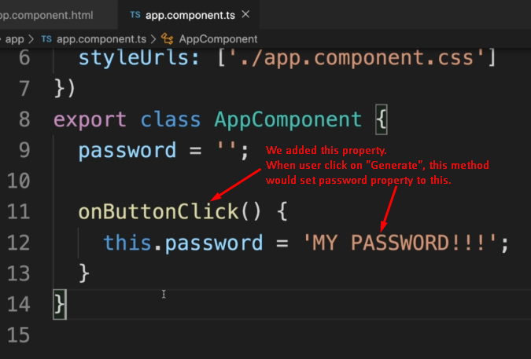
2. 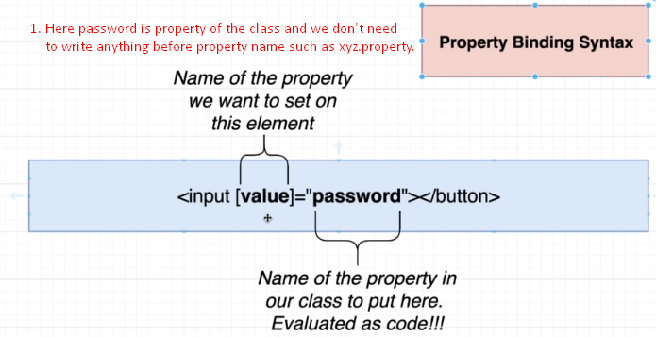
3. NOTE: if password property value is changed somehow, the corresponding change would be reflected to the UI automatically. 